Screen shot 1 of shell where we can see   
the contents of the directory and the package.json file. 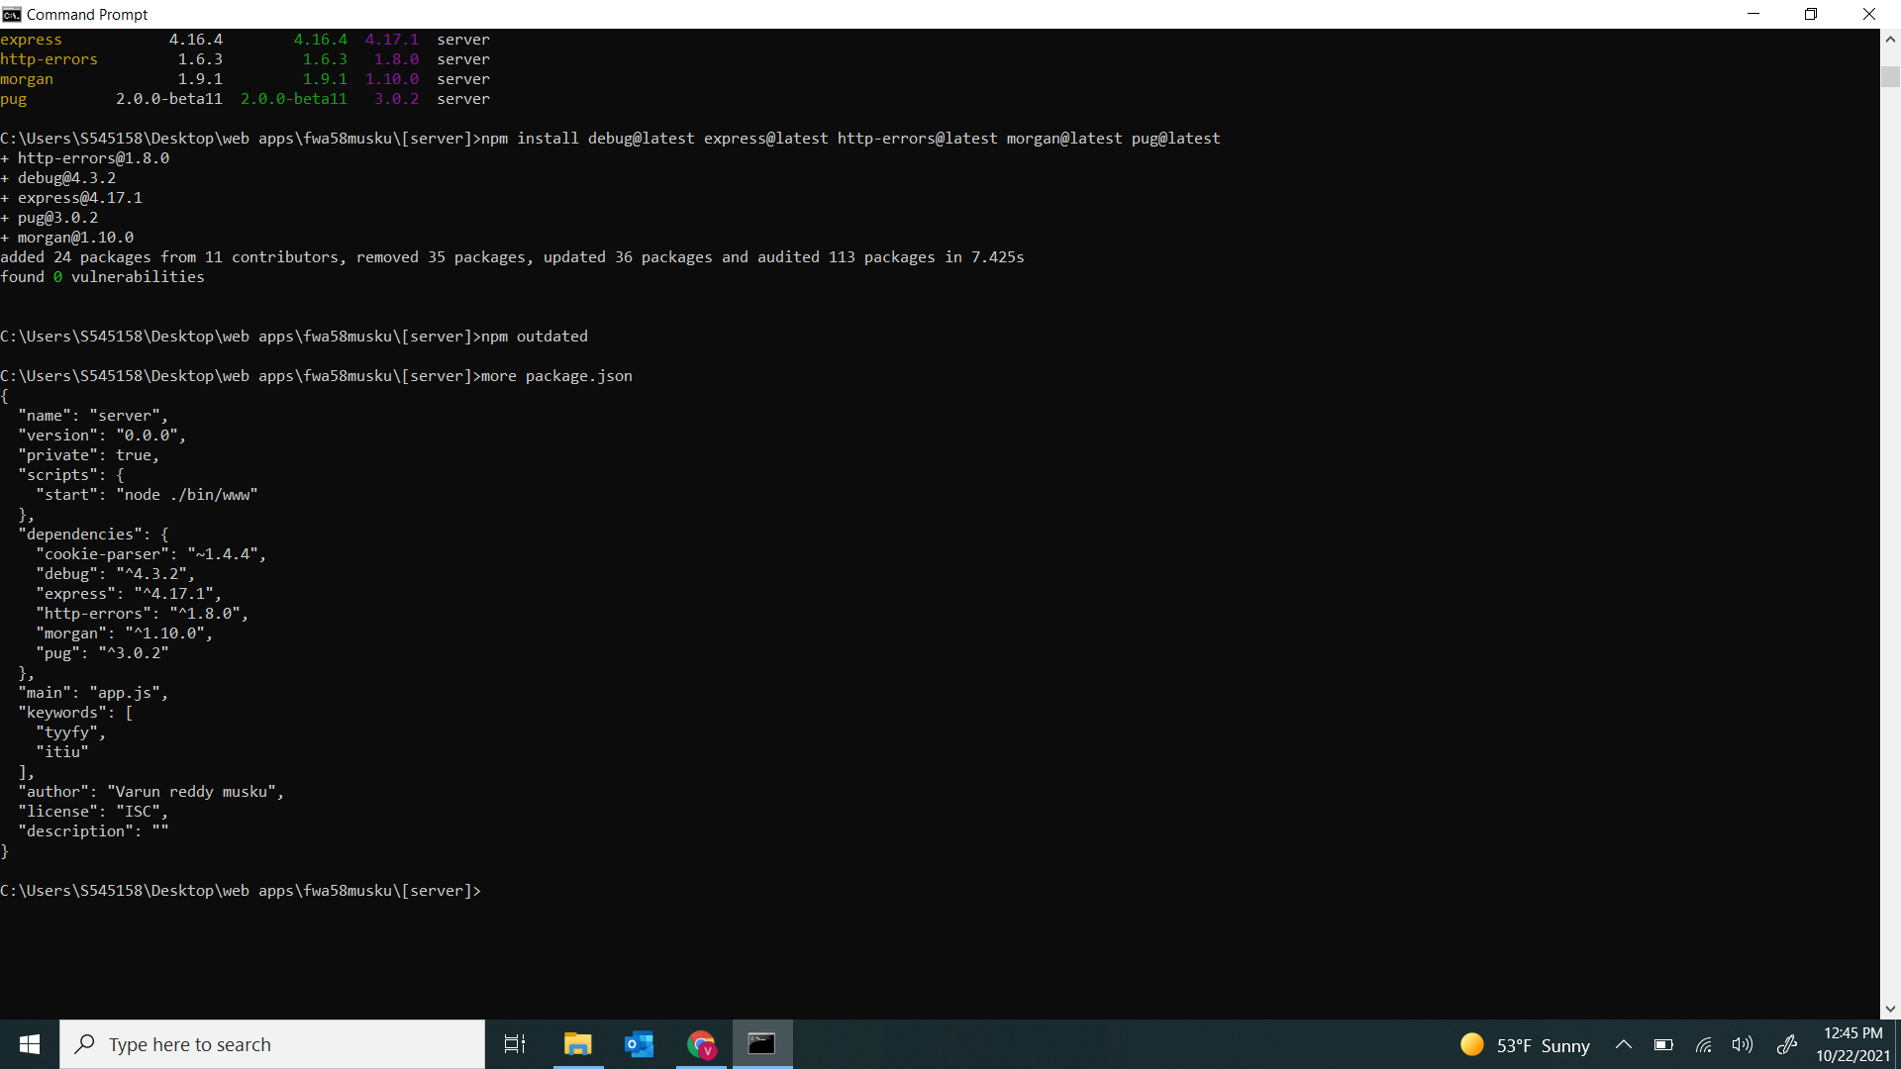

Screen shot 2 of browser for submission

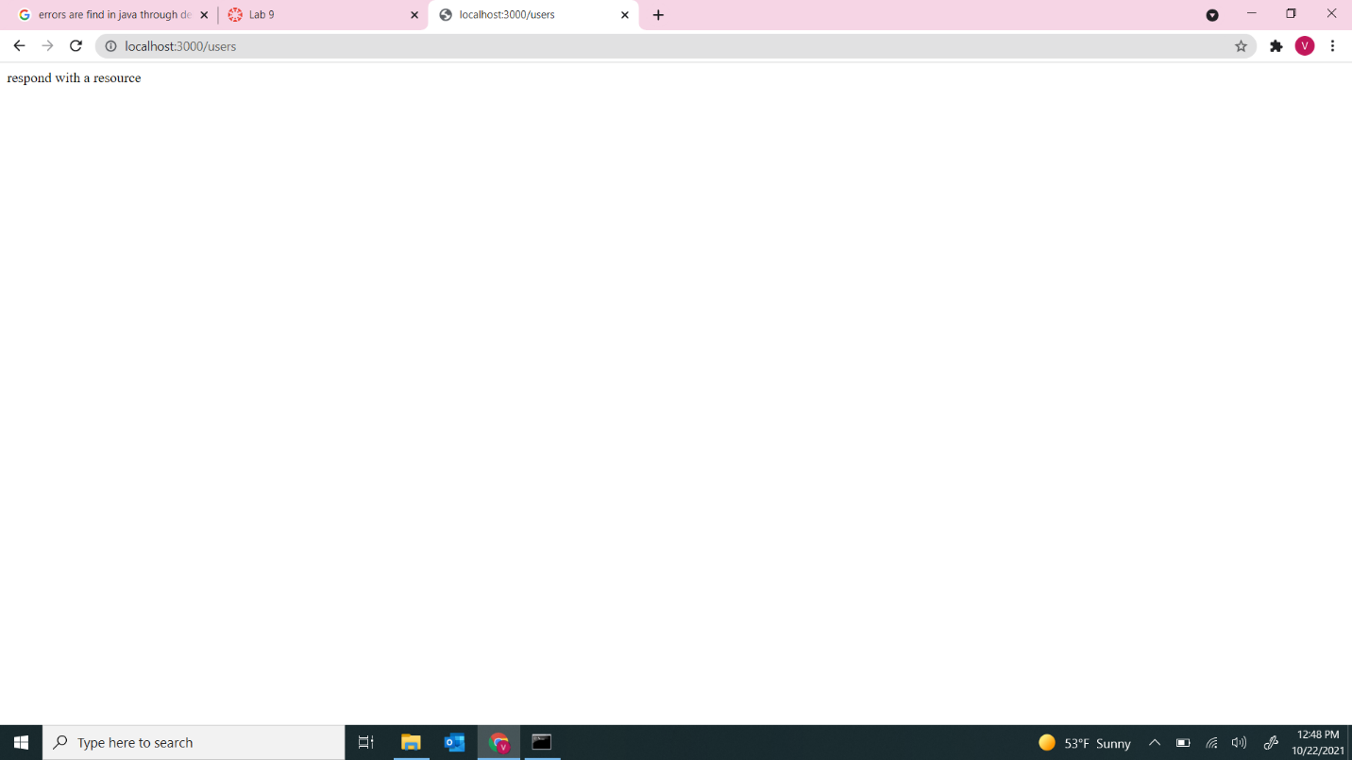

Screen shot 3 of repo on Github for submission.

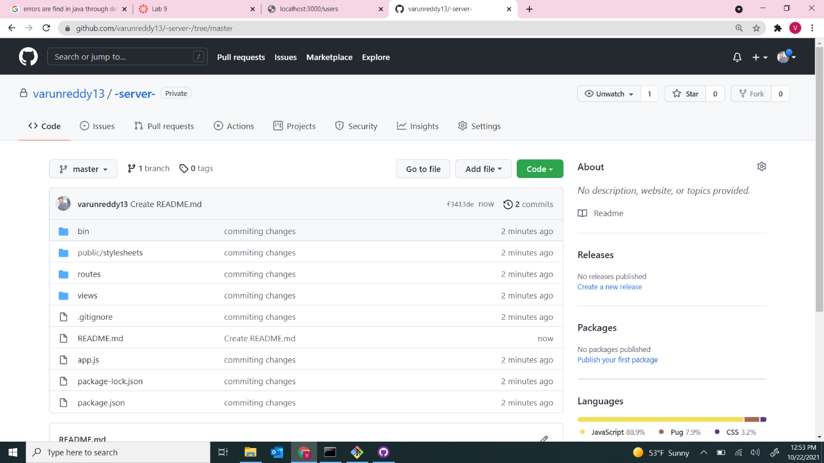

https://github.com/varunreddy13/-server-/tree/master